Review: Unit 4 Name _______________________
Angles and Polygons Signature _____________________
Part A
1. Estimate the size of each angle.
Name the angle
Use a protractor to measure the angle.
a) b) c) d)
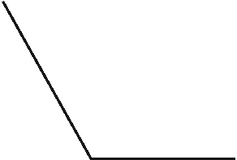

_____________ _____________ _____________ ____________
_____________ _____________ _____________ _____________
_____________ _____________ _____________ _____________
2. Use a ruler to draw an angle between 45° and 90°. Use a protractor to measure the angle you drew. Label the angle with its measure.

3. Use a ruler and a protractor.
Draw and label an angle with each measure.
a) 140° b) 90

c) 240 d) 40°

5. Draw a quadrilateral that has:
a) Exactly 2 right angles b) Exactly 3 acute angles

6. A triangle has angle measures of 35° and 55°. What is the measure of the third angle? Explain how you know.

7. A quadrilateral has three angles that measure 70°, 125°, and 35°. A student says the measure of the fourth angle is 120°.
Is the student correct? Explain how you know.

For each of the following determine the missing angle. DO NOT use your protractor! They are not drawn precisely.

